CURRICULUM VITAE

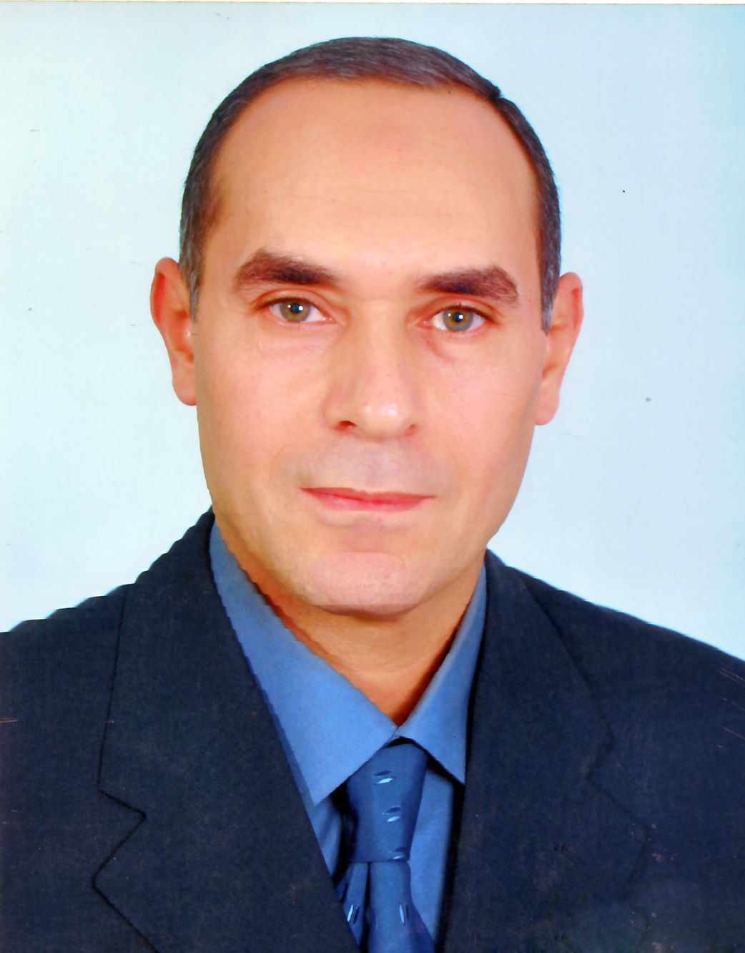

Personal history:

Name | :- Osman Mohamed Essam Abdelhafez Abdelrahem
Date of birth | :- Junary 1st 1963
Sex | :- Male
Residental adress | :- Hassan Elbakery street, Abrag Elbrahmia no.5, Assiut, Egypt
Work adress | :- Department of medical biochemistry, faculty of medicine, Assiut university, Egypt.
Marital state | :- Married and three children
Nationality | :- Egyptian
Occupation | :-Medical Biochemical Lecturer, faculty of medicine, Assiut university
E-mail | :- osmankoriem@yahoo.com
Telephone –Home | :- +20889201527,+20862638699
–Mobile | :-+20106809646

Medical and Academic Qualifications:

Date | Institution | Qualification
October 19 – September 1986 | Assiut faculty of medicine, Assiut university. | M.B.B.CH. (Bacchaloia degree) in human medicine and surgery, in September 1986.
March 1988 – March 1992 | Internal medicine department, Assiut university hospital, Assiut university. | Master degree (M.S.c) in internal medicine, in September 1992.
May 1994-May 1995 | Medical Bacteriology department, faculty of medicine, Assiut university. | Diploma degree in medical bacteriology, in May 1995.
May 1995- December 1999 | Medical biochemistry department, faculty of medicine, Assiut university | Master degree (M.S.c) in medical biochemistry, in December 1999.
December 2009 | Medical biochemistry department, faculty of medicine, Assiut university | Doctor degree in Biochemistry December 2009
Positions Held:
Position | Institution | Date
Resident in Internal Medicine department, Assiut university hospital | Faculty of Medicine, Assiut University, Assiut, Egypt. | 1988 - 1992
Demonstrator in medical biochemistry department. | Faculty of Medicine, Assiut University, Assiut, Egypt. | 1993 - 2000
Assistant lecturer in Medical Biochemistry department | Faculty of Medicine, Assiut University, Assiut, Egypt. | 2000- 2009
Lecturer in Medical Biochemistry department | Faculty of Medicine, Assiut University, Assiut, Egypt. | 2010 –till now

Teaching Experience:

Teaching and Examining for:
- Biochemical undergraduate students in faculty of Medicine, faculty of Pharmacy, and faculty of Veterinary Medicine, Assiut University.
- Biochemical undergraduate students in faculty of Medicine, Sohag University.
Teaching Courses are:
- Molecular biology.
- Enzymology. - Vitamines. - Minerals. - Hormones.
- Chemistry and metabolism of carbohydrates.
- Chemistry and metabolism of lipids.
- Chemistry and metabolism of proteins.
- Nucleotides metabolism.
- Xenobiotic metabolism.
- Oxygen free radicals and antioxidants.
- Heme metabolism.
- Immunoglobulins.
- Biochemical toxicology.
- Cancer biology.
Other Achievements and interest
Languages: Arabic-mother language .English-excellent
Computer Skills:
- Written and Internet searching.
- Performance of certain statistical analysis.
- Performance of data show and posters for presentation of lectures and researches.
Seminars and presentations
- New mechanisms of hormone action.
- Genetic base of atherosclerosis.
- Biochemistry of hypertension.
- Biochemistry of short stature.
- Biochemistry of prealbumin.
- Lipid storage diseases.
- Lipoprotien disorders.
- Disorders of purine metabolism.
Current Research Interest:
- Cancer biology, I also cooperate with colleagues in researches covering clinical chemistry and other interdisciplinary biomedical sciences.
- Past Research Interest:
- Biochemical disturbances in diabetes and Liver diseases. Nosocomial infections, Biochemical assessment of infections in critically ill children.
Clinical Experience (General/Subspecialty):
- Consultant of internal medicine, Ministry of Health and Population and Health insurance Egypt, 1995.
Attended Courses/Workshops:
- PCR
- Quality Assurance workshops.
Membership in Scientific Societies:
- Member of the Egyptian Society of Biochemistry & Molecular Biology, 1994.
- Member of the Egyptian Society of Cardio-Vascular Medicine.
Co-author and Coeditor for:
- Review of Medical Biochemistry, Faculty of Medicine, Assiut Univ.; Since 2000.
PARTICIPATION IN
- The National Conference on Viral Hepatitis and Hepatocellular Carcinoma,1996.
- Scintific Conference for the study of update in Hepatology and Gastroenterology, 2006.
- The NATIONAL EGYPTIAN CARDIOVASCULAR PREVENTION PROGRAM (DELTA-C PROJECT) JOHNS HOPKINS MEDICINE.
- The DELTA PROJECT (Diabetes Education Leveraging Therapeutic Advances).
- The Egyptian Society of Cardio-Vascular Medicine Conference, Alexandria, 2009.
- The 1st Scientific Congress of Medical Biochemistry department, Faculty of Medicine, Assiut University, 2005.
- The 2nd Scientific Congress of Medical Biochemistry department, Faculty of Medicine, Assiut University, in collaboration with The Egyptian Society of Biochemistry & Molecular Biology,and Mubarak City for Scientific Research and Technology, 2009.
- The annual Scientific Congress of the Egyptian Society of Biochemistry & Molecular Biology.
- Annual Scientific Conference of
Faculty of Medicine. 2002-2010.

